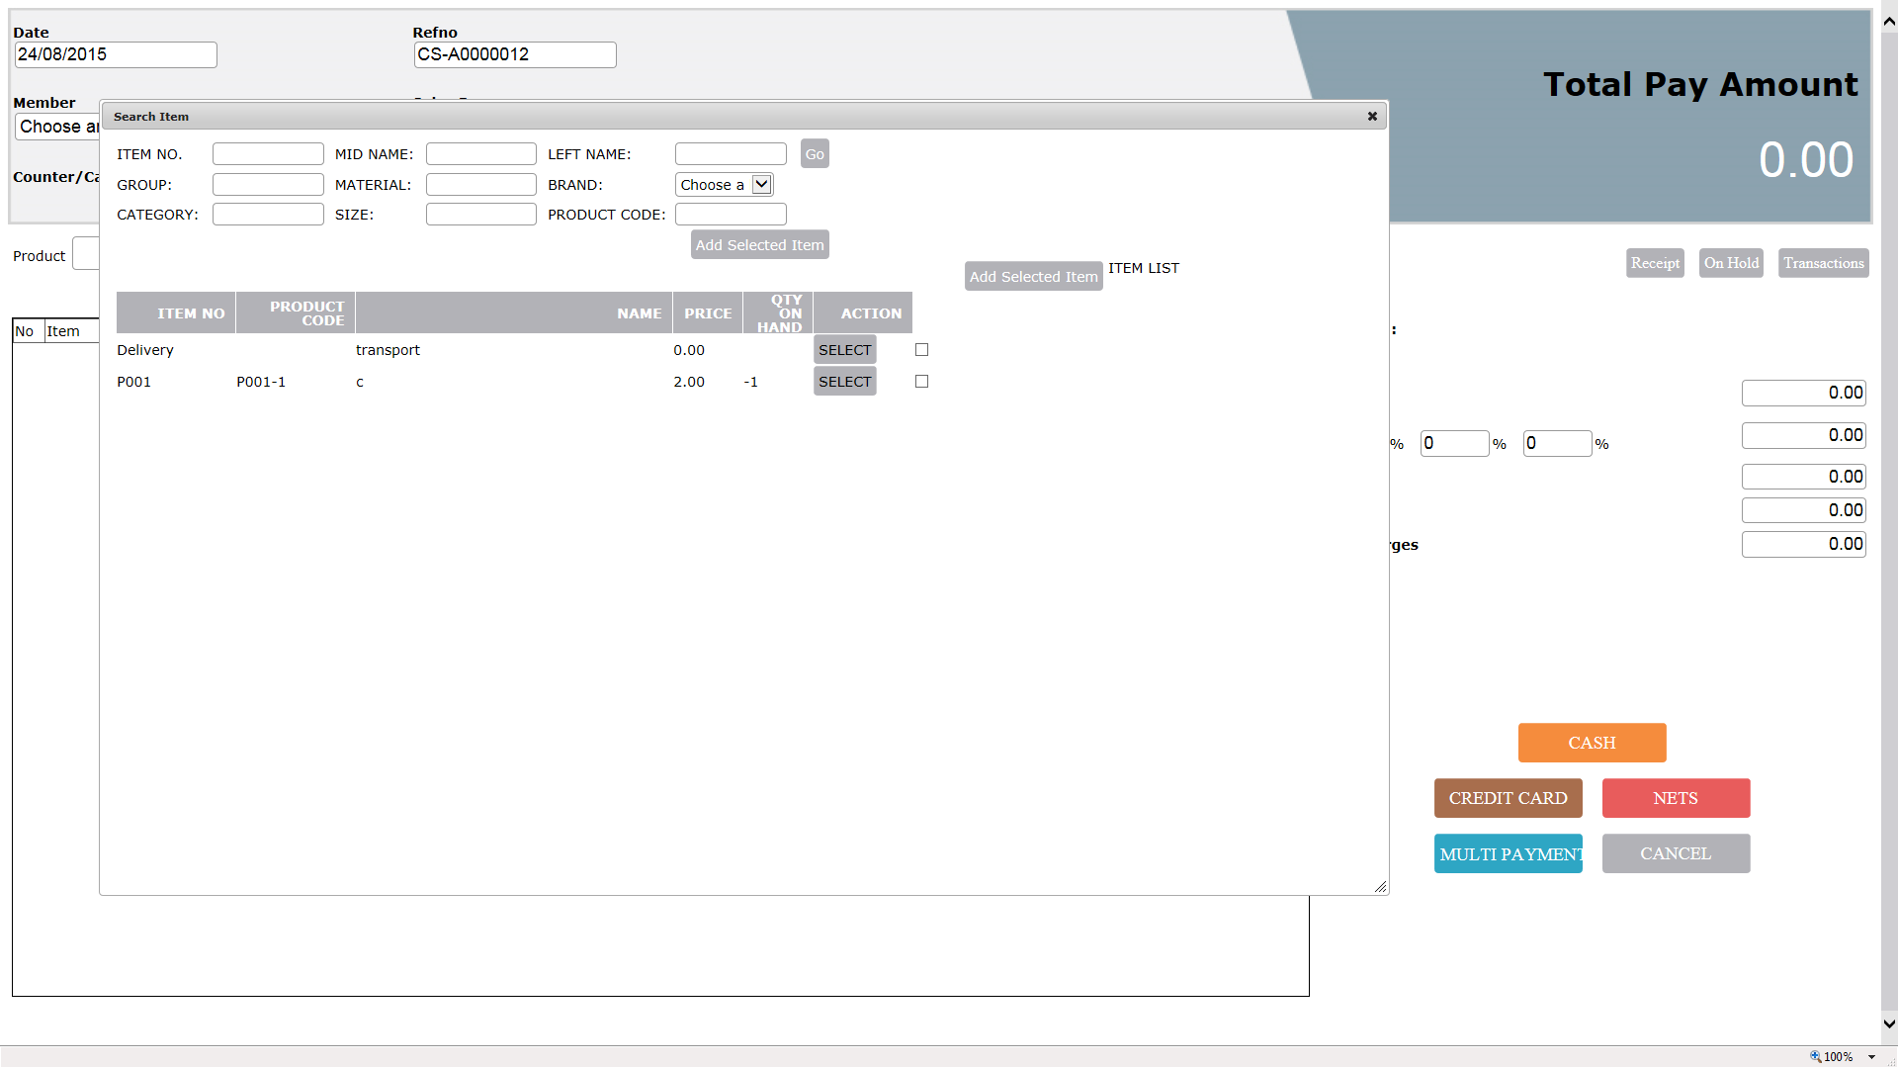

702, 1087, 1303, 2058, 585, 2057, 482, 1330, 786, 1335, 592, 1294, 1099, 1733,

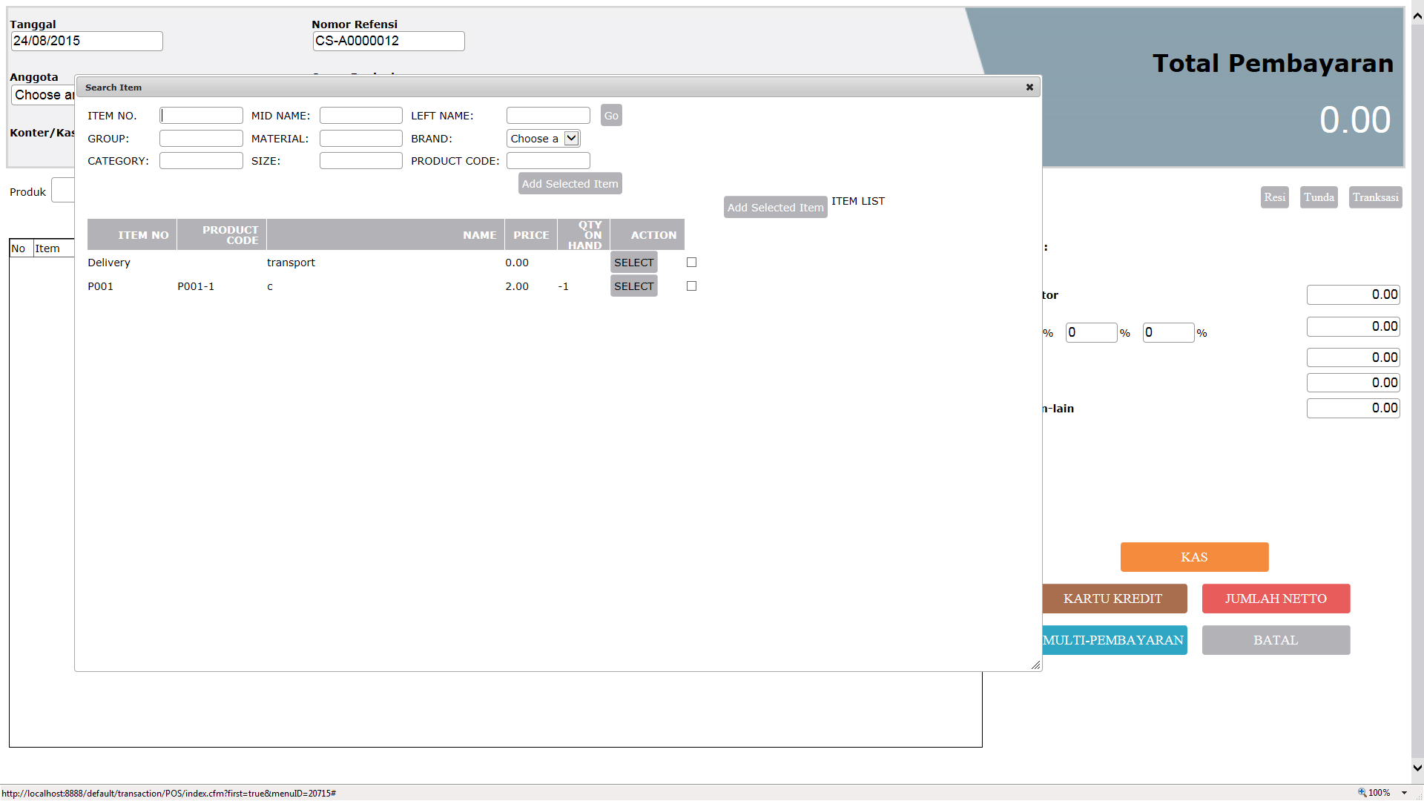
120,757,121,123,23,122, 2070, 1096, 133, 10

